**Lesson08 Azure Bastion host**

**Notes: -**

**1-Bastion Host: is secure server that is sites between public and private networks**

**(is managed service used to secure the internal virtual machines)**

**(like jump box for remote access)**

**2-Bastion Host offer multiple functionality:**

**A-Pass offering**

**B-RDS and SSH connect**

**C-Portal Access**

**D-html5 client**

**E-No public IP address**

**(so no need to assign public IP address for subnet that hold resources , and access to it through the RDS,SSH , all you need is to create subnet and set public IP address to it and then you can associate the other subnet with this subnet and access it through the browser )**

**(if you have multiple VNET, you have multiple Passion one for each Passion)**

**Prerequisites: -**

**1-need address range of /27 or larger for subnet called AzureBastionSubnet**

**2-VNET and AzureBastionSubnet on the same region**

**3-Html Client**

**3-so the operation is the following: -**

**A-the client browse through SSL within the azure bastion subnet and it will redirect to the target subnet or jump server that contains the resources , the only part hold public IP address is the azure Bastion host and the others no contains**

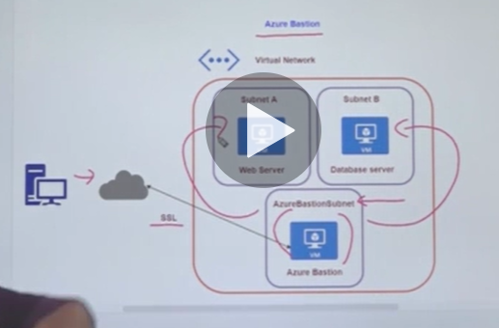

**Lesson09 using azure bastion host**

**Steps:-**

**1-we have to delete the jump server and all contents related to it**

**2-on the default subnet the hold the app, we will delete the RDP and the Allow_Jump_conntect_Def , and the public IP address is de assigned , because the public address is create on the Azure Bastion subnet**

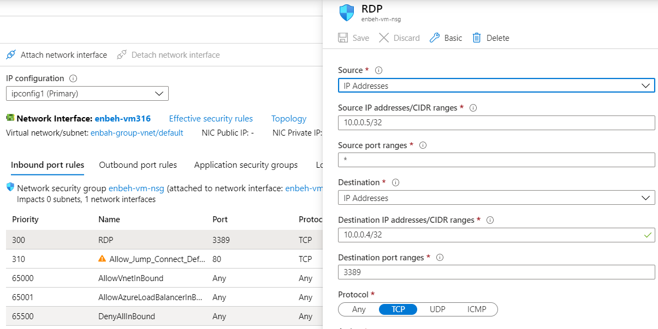

**3-on the azure VM 🡪 connect 🡪 we choose bastion (make sure that VM is start)**

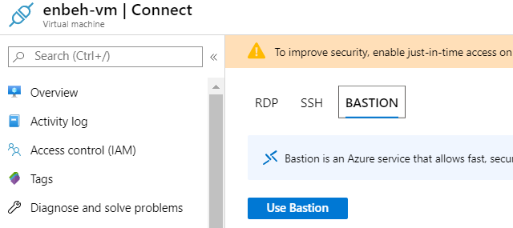

**4-on azure portal > virtual machine > click on the default VM > click on network > we click on IP space range and add new range**

**5-on azure portal > virtual machines > click on the default VM > click on the subnetwork**

**>we click on subnet and add new subnet on the created new IP range**

**the subnet name must be the name of the AzureBastionSubnet to allow Bastion connect**

**6-on the azure portal > Default VM > connect to Bastion > we set the Bastion connection and set new public IP address and create Bastion**

**//or on the resources > create Bastion resource**

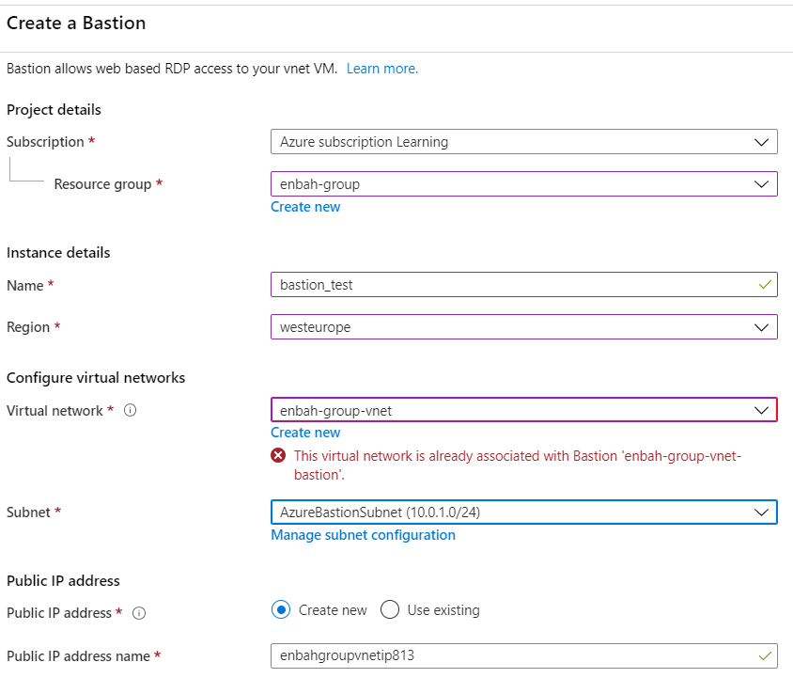

**(we see that the each Azure VNET has only one Bastion subnet and it’s associated with its private address range)**

**6-on azure > virtual machines > connect (select Bastion)**

**(and you will see that it ask for username and password)**

